LAB INDEX

NAME: Vivek Kumar SUBJECTNAME: Project Based Learning in Java Lab

UID: 21BCS8129 SUBJECTCODE: 20CSP-314

SECTION: WM-20BCS-616/A

|  |  |  |  |  |  |  |  |
| --- | --- | --- | --- | --- | --- | --- | --- |
| **Sr.No** | **Program** | **Date** | **Evaluation** | | | | **Sign** |
| **LW**  **(12)** | **VV**  **(10)** | **FW**  **(8)** | **Total**  **(30)** |
| 1 | Create an application to save the employee information using arrays. | 09-08-2022 |  |  |  |  |  |
| 2 | Design and implement a simple inventory control system for a small video rentalstore. | 23-08-2022 |  |  |  |  |  |
| 3 | Create a application to calculate interest for FDs, RDs based on certain conditions using inheritance. | 02-09-2022 |  |  |  |  |  |
| 4 | Create a program to show the usage of Sets of Collection interface. | 27-09-2022 |  |  |  |  |  |
| 5 | Create a program to set view of Keys from Java Hashtable. | 27-09-2022 |  |  |  |  |  |
| 6 | Write a Program to perform the basic operations like insert, delete, display and search in list. List contains String object items where these operations are to be performed. | 04-10-2022 |  |  |  |  |  |
| 7 | Create a menu-based Java application with the following options.1. Add an Employee2.Display All3.Exit If option 1 is selected, the application should gather details of the employee like employee name, employee id, designation and salary and store it in a file. If option 2 is selected, the application should display all the employee details. If option 3 is selected the application should exit. | 14-10-2022 |  |  |  |  |  |
| 8 | Create a palindrome creator application for making a longest possible palindrome out of given input string. | 01-11-2022 |  |  |  |  |  |
| 9 | Create a Servlet/ application with a facility to print any message on web browser. | 10/11/2022 |  |  |  |  |  |
| 10 | Create JSP application for addition, multiplication and division. | 10/11/2022 |  |  |  |  |  |

## CHANDIGARH UNIVERSITY

## UNIVERSITY INSTITUTE OF NGINEERING

**DEPARTMENT OF COMPUTER SCIENCE & ENGINEERING**



|  |  |
| --- | --- |
| **Submitted By: Submitted To:**  Vivek Kumar(21BCS8129) Neeru Sharma(E12950) | |
| **Subject Name** | Project Based Learning in Java Lab |
| **Subject Code** | 20CSP-321 |
| **Branch** | Computer Science and Engineering |
| **Semester** | 5th |

**Experiment - 10**

**Student Name: Vivek Kumar UID: 21BCS8129**

**Branch: BE-CSE(LEET) Section/Group:20BCS-WM-616/A**

**Semester: 5th Date of Performance: 01/11/2022**

**Subject Name:** **Project Based Learning in Java Lab Subject Code: 20CSP-321**

1. **Aim/Overview of the practical:**

Create a program that uses XML and html to create a DOM parser.

1. **Task to be done/ Which logistics used:**

Create a program that uses XML and html to create a DOM parser.

1. **Apparatus / Simulator Used:**

* Eclipse IDE - (Java)
* NetBeans.
* JDK-8 or any.

1. **Programs/ Code:**

**Code:**

***Index.jsp***

<%@ page language=*"java"* contentType=*"text/html; charset=ISO-8859-1"*

pageEncoding=*"ISO-8859-1"*%>

<!DOCTYPE html>

<html>

<head>

<meta charset=*"ISO-8859-1"*>

<title>Calculator</title>

<style>

**body**{

background: *black*;

color: *white*;

}

**h1**{

text-align: *center*;

}

*.Paramter*{

border: *2px solid white*;background: *blue*;

padding: *5px*;

max-width: *500px*;

margin: *auto*;

font-size: *19px*;

}

**button**{

position: *relative*;

left: *170px*;

margin: *10px*; width: *60px*;height:*30px*;

cursor:*pointer*;border-radius:*5px*;

}

**button***:hover*{

background: *orange*;

}

</style>

</head>

<body>

<br/>

<div class=*"Paramter"*>

<form name=*"funcitons"* action=*"*<%=request.getContextPath()%>*/functions"* method=*"post"* >

<h1>Mathematical Operation</h1>

<input type=*"radio"* id=*"add"* name=*"fun"* value=*"+"*> Addition <br/>

<input type=*"radio"* id=*"mul"* name=*"fun"* value=*"*"*> Multiplication <br/>

<input type=*"radio"* id=*"sub"* name=*"fun"* value=*"-"*> Subtraction <br/><br/>

Enter the First Value: <input type=*"number"* name=*"fst"*><br/><br/>

Enter the Second Value: <input type=*"number"* name=*"snd"*><br/>

<button type=*"submit"*>Submit</button>

<button value=*"Reset"*>Reset</button>

</form>

<h1>Ans = <%=request.getAttribute("ans") %></h1>

</div>

</body>

</html>

***Functions.java***

package unit3;

import java.io.IOException;

import javax.servlet.ServletException;

import javax.servlet.annotation.WebServlet;

import javax.servlet.http.HttpServlet;

import javax.servlet.http.HttpServletRequest;

import javax.servlet.http.HttpServletResponse;

/**

* Servlet implementation class functions

*/

@WebServlet(name="functions",urlPatterns={"/functions"})

public class functions extends HttpServlet {

protected void doPost(HttpServletRequest request, HttpServletResponse response) throws ServletException, IOException {

String a=request.getParameter("fst");

String b=request.getParameter("snd");

String fun=request.getParameter("fun");

try {

System.out.println(a+fun+b);

int i1=Integer.parseInt(a);

int i2=Integer.parseInt(b);

int ans=0;

if(fun.equals("+")) {

ans=i1+i2;

}else if(fun.equals("-")) {

ans=i1-i2;

}else if(fun.equals("*")) {

ans=i1*i2;

}

// System.out.println(ans);

request.setAttribute("ans", ans);

request.getRequestDispatcher("index.jsp").forward(request,response);

}catch(Exception e) {

System.out.println(e);

}

}

}

**OUTPUT:**

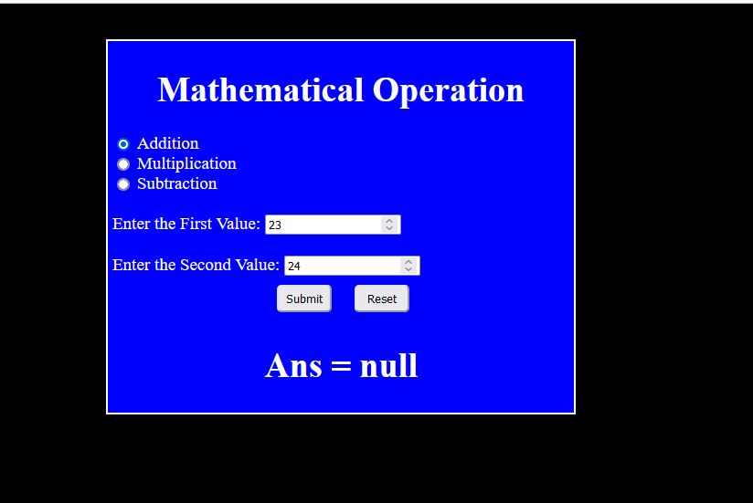

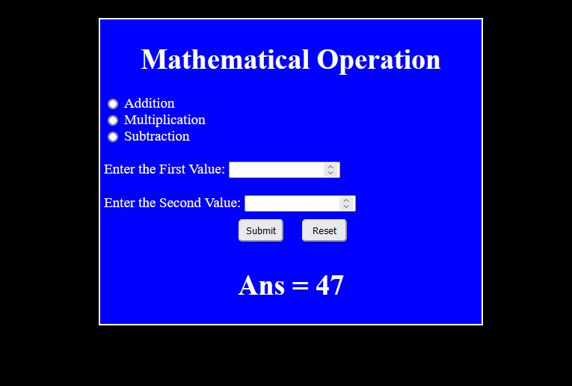

**Learning outcomes (What I have learnt):**

1. Learn About the servlet.
2. Learn about jsp and dynamic web project.
3. Learn about the tomcat server and its integrations with the java.

**Evaluation Grid (To be created per the faculty's SOP and Assessment guidelines):**

|  |  |  |  |
| --- | --- | --- | --- |
| Sr. No. | Parameters | Marks Obtained | Maximum Marks |
| 1. | Worksheet completion including writing learning objectives/Outcomes.  (To be submitted at the end of the day). |  |  |
| 2. | Post-Lab Quiz Result. |  |  |
| 3. | Student Engagement in  Simulation/Demonstration/Performance and Controls/Pre-Lab Questions. |  |  |
|  | Signature of Faculty (with Date): | Total Marks Obtained: |  |